* **NAME :ROSHNI RAZA**
* **SAP ID : 61278**
* **COAL LAB NO: 04**
* **TASK NO :01**

org 100h

.data

.code

main proc

mov dl, '6'

mov ah,2h

int 21h

mov dl, '1'

mov ah,2h

int 21h

mov dl, '2'

mov ah,2h

int 21h

mov dl, '7'

mov ah,2h

int 21h

mov dl, '8'

mov ah,2h

int 21h

main endp

end main

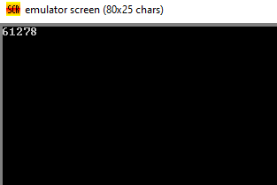

**TASK NO: 02**

**.**org 100h

.model small

.code

main proc

mov ah,1h

int 21h

sub al,'0'

add bl,al

mov dl, '+'

mov ah,2h

int 21h

mov ah,1h

int 21h

sub al,'0'

add bl,al

mov dl,'='

mov ah,2h

int 21h

add bl,'0'

mov dl,bl

mov ah,02h

int 21h

mov ah,4Ch

int 21h

main endp

end main

